**COLIN’S NOTES ON MOTION RECONSTRUCTION FROM IMU’S**

These notes summarise the issue that arise in reconstructing motion from the

accelerometers and rate gyroscopes signals recorded in IMU’s.

IMU’s were developed in the aerospace industry for the purpose of navigation

and were evolved to provide continuous tracking between known way points

provided by other fixed systems.

Wikepedia

IMUs are often incorporated into Inertial Navigation Systems which utilize the raw IMU

measurements to calculate attitude, angular rates, linear velocity and position relative to

a global reference frame. The IMU equipped INS forms the backbone for the navigation

and control of many commercial and military vehicles such as manned aircraft, missiles,

ships, submarines, and satellites. IMUs are also essential components in the guidance

and control of unmanned systems such as UAVs, UGVs,

SPERERO PTY recently attached IMU’s to locations on a horse to determine

motion, and developed a reconstruction approach based on the assumption of

cyclic motion during normal gaits.

The information derived IMU’s in this application included:

1. Gait Timing Information such as Stride Time and Stance time

based on the determination of hoof impact times and hoof roll-over times.

2. Determination of limb angle by integration of appropriate rate

gyroscope over the stride period.

Attempts to reconstruct IMU displacement was not successful with the approach

developed by SPERERO. This development revealed the limitations inherent in

motion reconstruction from IMU’s in the more general application to non-rigid

body motion.

Because displacement requires the double integration of acceleration

measurements, supplementary information is needed to define initial conditions

and correct for signal divergence due to sensor bias.

Some current research uses learning based systems to fuse visual-inertial learning-

based method, which runs in real time, and claims to outperform both visual-only and

inertial-only approaches.

The approach implemented by SPERERO pty assumed that Equine gait was a cyclic

motion and so the supplementary information used was that the velocity and

displacement and attitude angles at the end of a cycle equalled the velocity,

displacement and attitude angles at the beginning of a cycle.

This approach was demonstrated to work on a simple 2-dimensional pendulum motion

using the simple pendulum equations to simulate the IMU output.

For each IMU the standard kinematic equations of rigid body motion provide

expressions for the accelerometer sensor

ax = uD-rv+qw = gsin(the)

ay = vD –pw+ru- g cos(the)sin(phi)

az = wD-qu+pv-gcos(the)cos(phi)

The SPERERO reconstruction was developed for symmetrical motion with

variable in the direction X and Z and angle the. All other terms were assumed to

be zero

From which we can solve for the body axis velocity derivatives uD, and wD,

using integration to determine body axis velocity components u,and w

Euler attitude angles, (the) was derived by integration of the angular rate term

q.

The body axes velocities u and w are transformed into Earth axes terms ue and

we through standard axis transform equations

Finally Earth axis displacements are calculated by integration.

To represent measurement bias in the accelerometers, terms bax and baz are

added and used as variables to account for integration drift.

Initial values for velocity u0 and w0 are set and adjusted to achieve a closed

solution for displacements x and z

An iterative solution using Newton Raphson minimisation is used to calculate the

bias parameters and initial conditions. bax, baz,ue and we, to close the stride

cycle on velocity and displacement.

This process needs supplementary information to set initial values for

displacements X , Z and the.

This information is needed to establish motion relationships between IMU’s in

different locations.

An Important conclusion is that Supplementary position information is needed

to allow displacements between IMU locations to be related.

The only phase relationships that can associated between IMU’s are the direct

measurements of acceleration and rate, and not any variables derived by

integration.

**EXAMPLES OF RECONTRUCTION LOTS FROM UPPER PAKKY DATA**

Reconstruction plots from the IMU units on Left Fore Cannon, Poll and Sternum.  The plots are for 5 strides from Horse 1 and Run 1 and are longitudinal motion (angle and displacement). In the forward plane. For each case I have plotted the pitch angle against time and then the vertical displacement against Stride Distance.  Rather than plot displacement as though the horse was on a treadmill, I have assumed a walk speed of 4 kph and plotted against forward stride distance.

Given that we did around 6 or 7 walks with each horse, and we had 6 IMU’s mounted there is a lot of data to process.  I have plotted pitch angles for all four limbs and used that to determine the stride, stance and phase times summarised in the XL sheet I sent previously for Horse 1 and Run 1. So, I feel once the data is analysed and collated for the three horses we should have a good data set to relate head movement to limb movement and to define the ranges of movement across horses.

STRIDE RECONSTRUCTION --- UPPER PAKENHAM 08.04.2021

Reconstruction of motion from IMU units

Angles plotted against time Displacement against stride distance

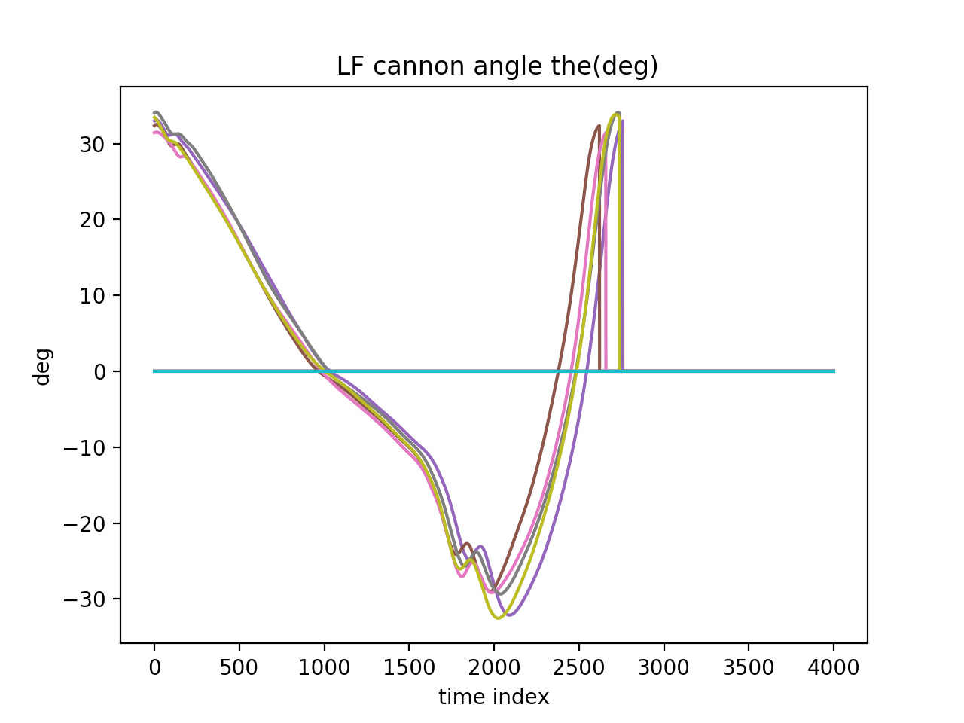a) mounted to the left Fore Cannon IMU V3.7 No.11

b) IMU V3.7 No.16 mounted on Sternum (Note graphs titled incorrectly)

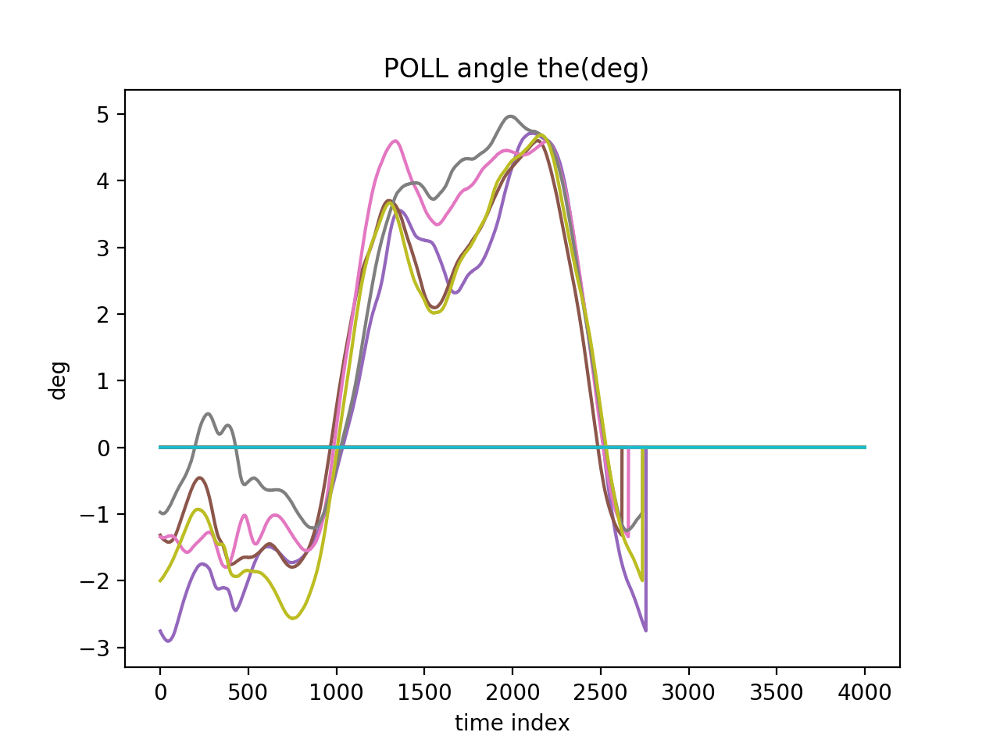

c) IMU V3.7 No.15 mounted on Poll (Note graphs titled incorrectly)

